To the left is what I expect
the values of each process
to be for each iteration of ticker, and I've marked the changed values after each iteration with red font; to the left is the output I got that corresponds with my expectations.
Process arrival runtime priority
0 0 3 0
1 2 3 2
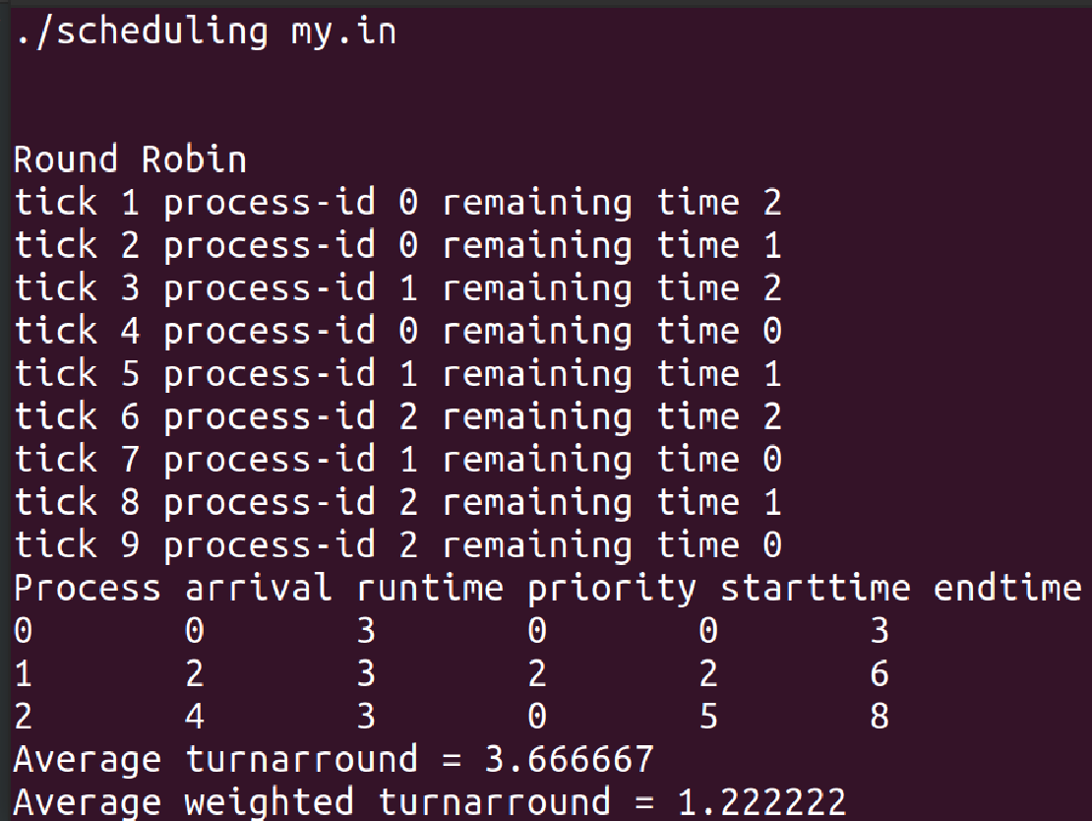
2 4 3 0

ticker p0 p1 p2
0 3 3 3
1 2 3 3
2 1 3 3
3 1 2 3
4 0 2 3
5 0 1 3
6 0 1 2
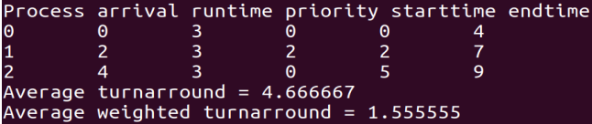
7 0 0 2
8 0 0 1
9 0 0 0

Process arrival runtime priority
0 0 3 0
1 0 3 2
2 0 3 0
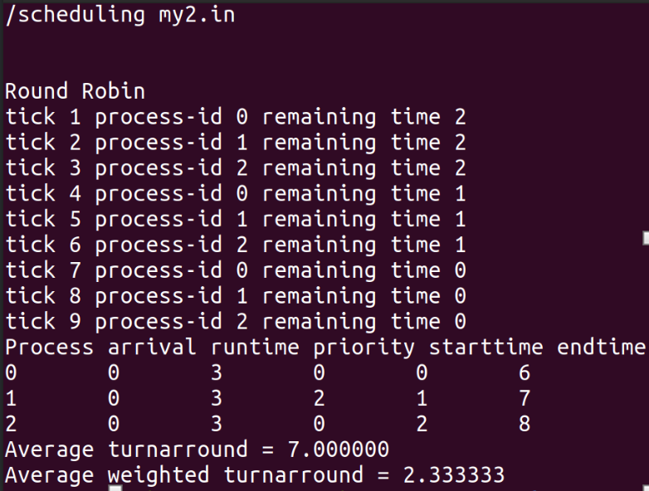
ticker p0 p1 p2
0 3 3 3
1 2 3 3
2 2 2 3
3 2 2 2
4 1 2 2
5 1 1 2
6 1 1 1
7 0 1 1
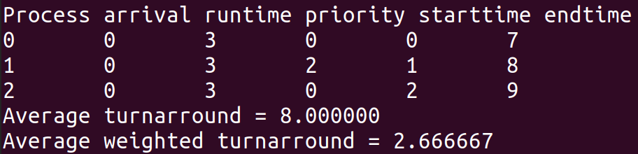
8 0 0 1
9 0 0 0
Process arrival runtime priority
0 0 6 1
1 2 3 2
2 5 3 0
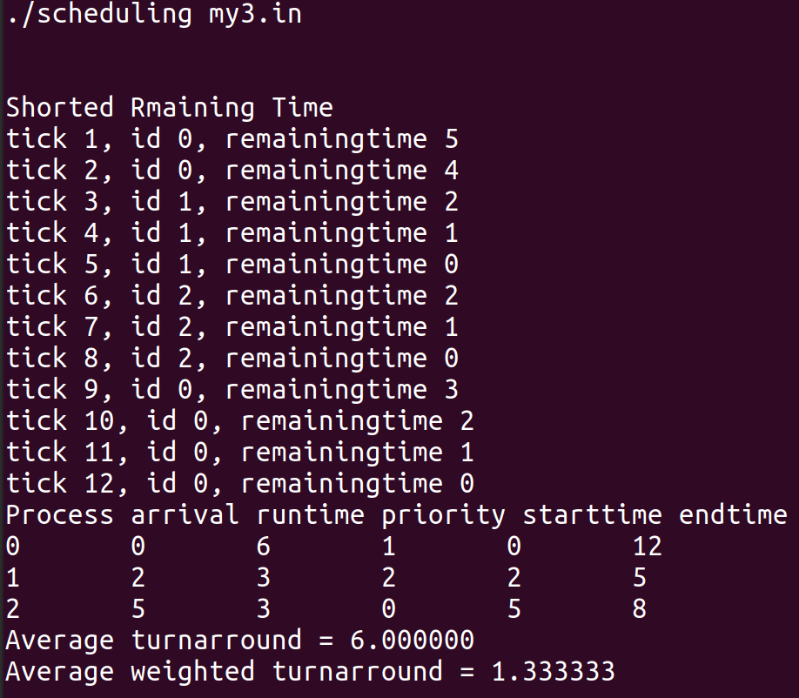
ticker p0 p1 p2
0 6 3 3
1 5 3 3
2 4 3 3
3 4 2 3
4 4 1 3
5 4 0 3
6 4 2
7 4 1
8 4 0
9 3
10 2
11 1
12 0

Process arrival runtime priority
0 0 3 0
1 2 5 7
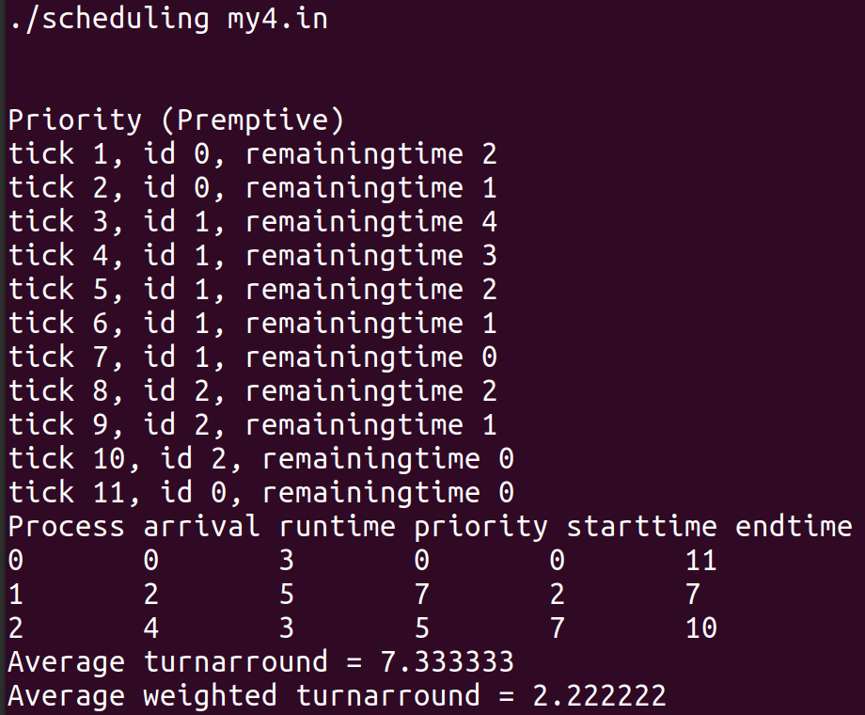
2 4 3 5
ticker p0 p1 p2
0 3 5 3
1 2 5 3
2 1 5 3
3 1 4 3
4 1 3 3
5 1 2 3
6 1 1 3
7 1 0 3
8 1 2
9 1 1
10 1 0
11 0

